Sustaining Native Bee Populations in Developed Areas
Senior capstone research paper
Kelly Zhang

Contents
Introduction & Background 2
Education 4
Educating the Public 4
Pesticide Use 4
Building Habitats 6
Concerning Invasive Species & Disease 10
Facing Complaints 10
Survey Results & Evaluations & Personal Research 11
Advocating (Optional?) 13
Concluding Thoughts 14
Appendix 14
I. Nest/Hive Structures 14
II. Building Mason Bee Nests 14
III. Are Honeybees Competitive with the Native Bees? 14
IV. Local Observations 14
Works Cited 19

Abstract

We all hear about the honeybee on a population decline, but have we ever considered native bees a part of this too? Native bees have been subject to habitat destruction and pesticide poisoning through human action, especially in urban and suburban areas. This research paper is dedicated to finding ways in which people can partake in bringing back native bees to the cities. In the latter half of the paper, I will report my findings and evaluate how Newton does on native bee conservation.

Introduction & Background

Native bees are all around us, yet we don't acknowledge them as actual bees like we do with the honey bee. The very few that we do acknowledge, are typically bumblebees and carpenter bees but those are only a few out of the 4,000 that exist in the United States. Native bees provide just as much pollination services, if not more, than our honey-making friend. With the recent Colony Collapse Disorder ordeal surrounding honeybees, many have been chanting “Save the bees!” but should we really be saying that if the word “bees” only meant honeybees?
There's a difference between the honeybee and the native bee. Honeybees originated from Europe and were brought to North America by colonists for honey stores. Honeybees are social bees, meaning they live in a colony with infertile female worker bees and a single fertile queen bee. Some native bees are social too, such as the bumblebee and various species of sweat bees, but the remaining majority is solitary, meaning each female bee is its own queen and lays its own eggs. Unlike the honeybee, native bees do not produce honey, and those that do produce only enough for the young to feed on. Honeybees are not so picky with the flowers that they pollinate, but they do not have certain abilities to efficiently pollinate specific flowers. The tomato plant for example, can only be pollinated by buzz pollination, a technique in which a bee vibrates its wings to shake the pollen from the flower and onto its body. Bees like the bumblebee are able to perform this. Other bees like gourd bees specialize in pollinating cucurbits (melons, squashes). At a third of the size of a honeybee, the gourd bee can pollinate the (x times) (SOURCE) more than the honeybee. Not all bees live in hives that are up on trees either. 70% of native bees actually burrow into the ground like their ant cousins. The remaining 30% burrow in hollow logs and stems. (SOURCE) Even though these bees do not create waxy honeycomb hives, the concept in which the burrows are built are very similar. (See Appendix)
For my research project, I have focused on conserving native bee populations in developed areas (urban and suburban). Coastal regions typically have the highest biodiversity of animals and insect but it is also a region where many of our big cities reside in. (SOURCE) By destroying the native land for infrastructure, we are essentially destroying the homes of several hundred, if not more, species. Inappropriate pesticide uses in these areas are an additional problem for any surviving species left. It is important to educate the public on these issues in order to help sustain native bee populations in developed areas. Through that, I will be going through ways a person can help their local bee populations out, even if they live in a small apartment complex in the city.

Education

Educating the Public

Education of the public is one of the great overarching solutions towards native bee conservation. In a place where not as many people have the time or space to cultivate bees, awareness is key. It is vital that people are given accurate information about bees, or else misconceptions and wrong-doings will occur. Just because some bees sting doesn’t mean all bees do. Knowing how to differentiate bees, how to tell between native plants are non-native ornamentals, how to tell when how much pesticide is too much, or even being aware of the pollinator situation and calling your local legislator about it – all of these alone can contribute to help conserve bee populations, and if done in the right way, can be a greater help.

Pesticide Use

Pesticides may aid us in growing beautiful crops but it does not do any justice to the insects and animals that are pollinating it. In the context of bees, using pesticides diminishes populations of these pollinators and given that they are harmful enough, pesticides can even have long term effects on its consumer. In the 2009 documentary film “Vanishing of the Bees”, French scientists have said that systemic pesticides such as neonicotinoids can affect bees across generations. These types of pesticides are applied on the seeds, making the pesticide spread throughout the plant as it grows, sometimes even to its reproductive system where the bees harvest pollen from. While bees that collected the pollen might not be immediately affected, active ingredients in these pesticides can cause genetic alterations that can make offspring more susceptible to diseases. (Hive Mentality Films & Hipfuel Films 2009)
In urban environments, it’s even worse. Unlike farmlands, where the government can regulate how much pesticide is distributed to farmers, urban landscapes are oversaturated with store-bought pesticides. In a 2009 study by Northeastern University, 1/3rd of the Jamaica Plain neighborhood is at a medium to high environmental risk. Most of this is due to toxic wastes and the excess use of pesticides. It was explained in the report that when spraying, companies do not coordinate spray times with each other and often spray them in the same areas at the same time. It has gotten to the degree of toxicity where not just bees are at risk but also humans— children especially. (Neighborhood Pesticide Action Committee 2009) This is only one small community out of the many in Massachusetts. One might argue that other areas may not spray pesticides as much, but that doesn't mean that such places should be excused. Bees are all still affected by this. We use pesticides, herbicides, fungicides, and the likes the eliminate the things we consider ugly in our gardens or natural landscapes, but what happens if the creatures that make our environments beautiful and flourishing go down with them as well?
There is also an alternative to using bee-safe pesticides, but it has proven ineffective. Like all chemical drugs, there's always a negative side-effect. Unlike common pests, bees are not well adapted to pesticides overtime.
So what can be done about this? Pollinator Partnership states that “emphasis must be on a thoughtful, educated approach to chemical use, and to a reduction and ultimate elimination of its use.” One of the main problems when it comes to applying pesticides is when to spray them. If one must spray pesticides, they should consider the times in which pollinators come out to forage.
The use of cover crops greatly benefit pollinators such as bees. Cover crops are primarily used to maintain the quality of the ecosystem around it. Many of its benefits include maintaining soil pH levels, combating weeds, and nutrient retention in the soil. While the upside is that there’s no need to apply herbicides to your garden, the downside to this is that it attracts a plethora of insects, both good and bad. Bees happen to be one of good guys, looking for a place to hide and rest in during their foraging trips. Alfalfa is an example of a cover crop and is a favorite of the bees. Thankfully, growing alfalfa can also attract predatory insects to combat the pests.

Building Habitats

Habitat building for native bees is the best way to sustain their survival. This can be done in your own garden, or at one that is run by the community. Community gardens are great for people who can’t grow one at home. If there isn't a community garden in your area, there’s always the opportunity to start one. Growing a garden not only strengthens the community, but also the native life that frequent the area, like bees. In the words of Xerces conservation expert Kelly Gills, “People can plant a diversity of flowers no matter how big or small the space they have.”
Because of their long history with certain native bees, native plant species are a wonderful addition to a garden. Expert Roger Wiegand, an entomologist, said that he identified over 40 different native bee and wasp species visiting the nepeta in his yard in a 15 minute interval. However, planting one type of flower is not enough. It is extremely important to have many different types growing in your garden as “diverse or complex landscapes, which contain a variety of plant types including flowers, shrubs, and trees, tend to have higher rates of natural enemies (particularly parasitic wasps) than simple landscapes do.” (Cloyd, Nixon and Pataky 2004) You wouldn't like to stop at a restaurant that only sells caesar salad or only meatball subs. A mix of annuals and perennials is preferred since not all the flowers in your will die at once when the fall and winter season comes around.
Planting flowers of a variety of shapes and sizes will also attract certain bees which specialize in collecting from them. Flowers like [ ] which are long and tubular attract specialty bees like bumblebees and orchid bees. On the other hand, flat surfaced flowers such as [ ] attracts a wider variety of bees due to easier accessibility to pollen and nectar. Planting shrubs and bushes are good for giving bees shelter from outside dangers. One of the biggest factors contributing to population decline is the removal of these shelter plants. Without these, bees are more susceptible to precipitation, temperature extremes, and predators.
Another tip is to let the grass on a lawn to grow long so as to leave added protection for any of the grown-nesting bees. If you must cut the lawn, it is best to raise the blade so that the grass is not cut extremely short. (Attracting Native Pollinators)
Currently, there has been a widespread movement to encourage habitat establishment for pollinators in the United States. John Schwartz from the New York Times writes that,
“The federal government has announced a new $3 million program to step up support for honeybees in five states in the Upper Midwest…
The new program will encourage farmers and ranchers to grow alfalfa, clover and other crops favored by bees and which serve a second purpose of being forage for livestock. Other proposed changes in practices include fencing property for managing grazing pastures in rotation so that they can replenish, leaving living plants for the bees.
Jeffery S. Pettis, who leads bee research at the federal Agricultural Research Service in Beltsville, Md., said the effort to get farmers to plant more crops with pollinators like bees and butterflies in mind was intended to help the creatures weather the challenges of pathogens, parasites and pesticides. “If they have a good nutritional foundation, they can survive some of the things they are faced with,” Dr. Pettis said.”

While this government program does not focus on developed areas, it does show that something is done about this issue, and that practices done out in the farm can be modified so that it can be applied to the cities.
Of course, what goes around comes around. Building habitats for bees will definitely cost money, time, and space. Despite this, what we get in return is much bigger. More habitats mean more bees and pollinators. More bees mean more pollination services. More pollination means more fruit obtained. Not only is it beneficial to the environment but also to our well-being. Kaat noted that beekeeping has psychologically impacted her in a positive way. And it wasn't just her; beekeepers in her community said the same thing. It's the feeling of being able to do something, that “yes, I can do this and I be part of the change.”
So what about establishing habitats in places with a lot of people? People may have concerns over allergies, stinging, and infestation. Many of these can be avoided if the right thing is done about it.
In case studies, there has been a push to set up multiple urban gardens throughout all of California. All throughout blooming season, several bees native to California show up and visit these gardens. Organizations like Xerces have also been pushing to establish pollinator friendly environments in places such as Minnesota and Wisconsin. Here in Boston, Massachusetts, a small business called BestBees has been setting up bee hives and bee nests on the rooftops of company buildings. While these beehives are specifically for raising honeybees, similar ideas can be implemented so that companies can endorse the installation of native bee hives and pollinator gardens as well. Currently companies like Crown Bees, have been going through this approach, selling mason bees and mason bee nests.
Building bee nests/houses is another way to help the survival of bees, especially in areas where there is a lack of places for tunnel-nesting bees to find hollow areas to live in. This allows bees around the area to have a safe place to rest and lay their eggs. For part of the field study of this project, I have decided to build several bee houses for tunnel nesting bees. (Pictures in Appendix) It wasn’t as smooth as I expected, for many reasons. First was building the nests themselves. I have no experience in woodworking, nor did I have understanding of the types of materials I was supposed to use. However, guides like the one from Xerces helped me tremendously. The second issue was finding places to put the nests. Newton’s environmental leadership community, Green Decade, has lent a tremendous hand in putting up an ad on their e-newsletter, but unfortunately I did not receive any replies from their subscribers. Regardless, I have put them up outside of my house, and my grandparents’ house. I built two types, one with holes drilled into a log and one with hollowed out bamboo poles. The process is fairly simple, though certain precautions need to be taken in order for the bees’ health to not be at risk when they are inside the housing. The other issue to this is the timing and weather. While I have left these houses out for the bees to nest in, the New England area has been subject to a lot of temperature extremes as of late, making even bee sightings difficult.

Concerning Invasive Species & Disease

Facing Complaints

As much as you want to help the bees out, your neighbors might not be as enthusiastic as you are. Many fear the sight of a group of bees, and are most likely tempted to rid of it in a way that harms the bees. Before setting up your bee-friendly garden, you should negotiate with neighbors with your plans and clear any sort of concerns they might have.

Survey Results & Evaluations & Personal Research

In a survey that I did for evaluating the public's opinion on bees, a majority said that bee conservation is important to them. There are many issues with the results in the survey however. For one, 63 responses is not an optimal number to be extrapolating data from. From those 63 people, almost 90% are 29 or younger. However more than 50% of the 63 consider bee conservation important to extremely important, meaning that bees will not be looked at in the negative light 20 to 30 years from now. 73% said that they would actively advocate to build pollinator friendly gardens in their communities and 56% said they would change the way they ate to help bee conservation. Even though about 80% of the responses came from people living in urban or sub-urban areas, there was a mix of responses on how important bee conservation was to them and how willing they were to actively advocate. In the case of finding a bee nest around the vicinity of their house, there was a major thirds of a split between “Leave it alone”, “Call a local beekeeper”, and “Call pest control”/ “Attempt to remove it yourself”/ “Other”. Out of those who answered “Attempt to remove it yourself” responses are either burning it down or spraying it down.
In addition, the survey asked people “How many kinds of bees can you list off the top of your head? What are they?” A majority have correctly identified at most 2-3 bees. In order of most frequently identified to the least are: honeybee, bumblebee, and carpenter bee. All others were identified about 10-20 times, and included insects that weren't bees (hornet, yellow-jacket, wasp) and then
I have also contacted several experts in the field on this issue. Many them have focused their expertise on honeybees but provided a great deal of insight on what it’s like to be in this conservation movement. My first contact was Kelly Gills, a conservation expert from Xerces Society.
I have also been doing bee watches in the Newton area, or at least attempting to. To my surprise, it was only until early May have they been actively showing up. It was rather frustrating not getting to see a bee before then, but I figured that the crazy weather going on in April delayed their appearance, or endangered them. Pam Philips, a local bee enthusiast has confirmed that,
“The cloudy cool weather lately has not been the greatest for bees. It's also still pretty early. This time of year on sunny days you'll most likely see bumblebees hunting for nest sites. On warmer days honeybees will be foraging. You may also find small brown bees emerging from the ground or lawns. These are Miner bees. They are only active for a few weeks in spring.”

Upon further observations, I found out that despite how lush and green Newton appears to be, many of the blooming flowers that were popping up were not native plants, but non-native ornamentals. When going down Walnut St. and Watertown St. I see rows and rows of giant Bradford pear trees blossoming their smelly white flowers. These trees are considered as invasive species, but both the honeybees and the native bees seem to favor their smelly scent as an indicator for rewarding nectar. At the same time, I have been seeing honeybees feasting on native blue violets popping up all over the sidewalk grassbeds. Even though they are considered weeds, flowers like the blue violet still provide pollen and nectar for bees to harvest from.

Advocating (Optional?)

Advocating is the next step of action towards bee conservation. Once the general populous is aware of the critical situation our pollinators are in, pressing this issue towards government and private corporations will show them that not only the farmers and beekeepers in the rural areas are concerned.
I spoke to Kaat one day on this issue. Kaat is an active advocator for many environmental issues that are currently going on, such as Pipeline XL. When starting her activism, bees weren't on her mind, but eventually found out their importance in her gardens and began raising bees. Now, in addition to raising concerns about Pipeline XL and Governor Deval Patrick's climate legacy, she has also gone to local Home Depot and Lowes stores in Massachusetts to protest the use of pesticides that are harmful to bees.
Advocating can be done in many other ways. One of them would be to protest with your fork and eat organic foods and/or buy locally from places you know that don't use pesticides. It may be a slower process; in a capitalistic society money speaks.
Joining
Bee populations all over the world are slowly declining, and if we don’t do more for them, pollination for flowers will be scarce, and then crops would have to be pollinated by humans instead. This is an issue that must be done as soon as possible. Thankfully, there are plenty of organizations that are actively finding solutions towards pollinator conservation. The Xerces Society is one of the more well-known ones. Their efforts alone aren’t enough to solve the problem. It takes entire communities to work together to make a difference. If every family were to grow a small pollinator friendly garden, use bee-friendly plants, or even change the way they ate, bees would slowly come back, and corporations, even the government would start to make changes.

Concluding Thoughts

Appendix

Nest/Hive Structures

Building Mason Bee Nests

Are Honeybees Competitive with the Native Bees?

Local Observations
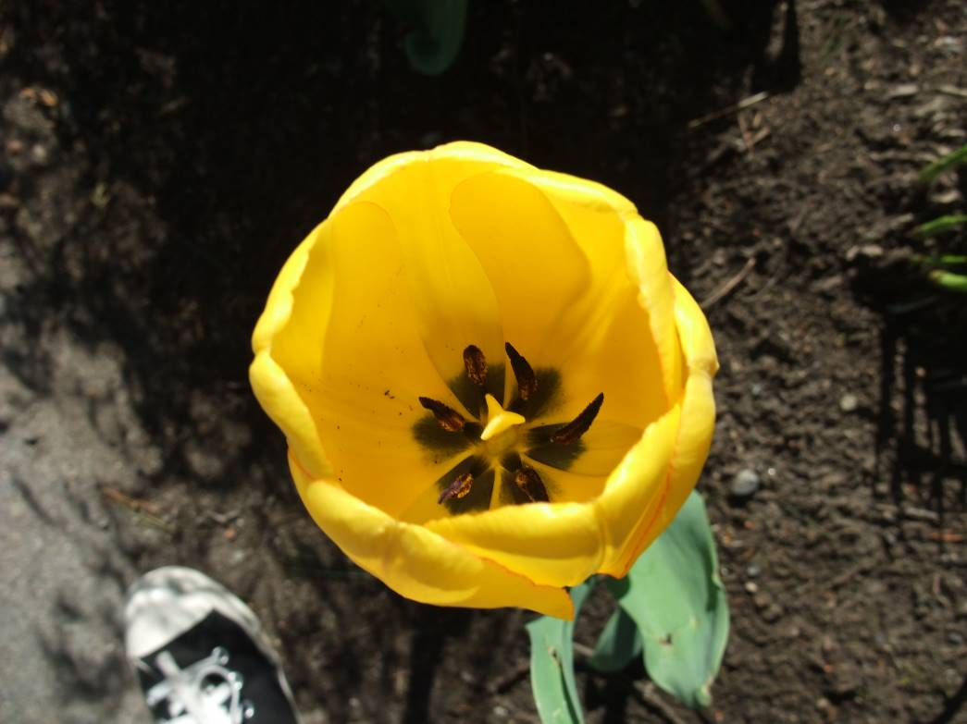 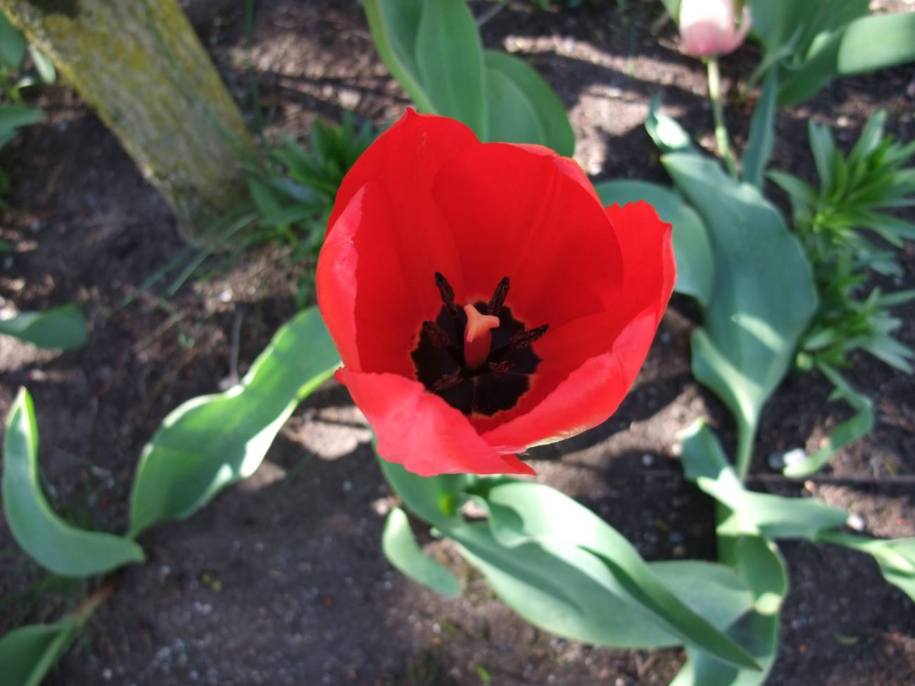Figure 1. I took pictures of two tulips in a front yard garden on Cabot St. As beautiful as they were their anthers (the brown stems surrounding the center) were barely covered in pollen.

Survey Results
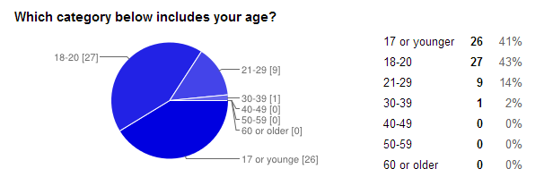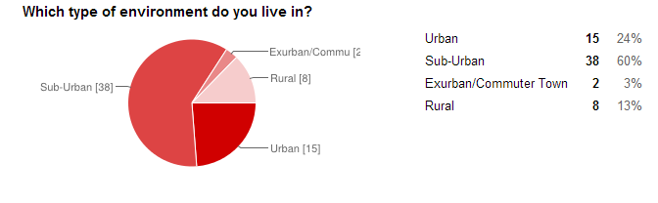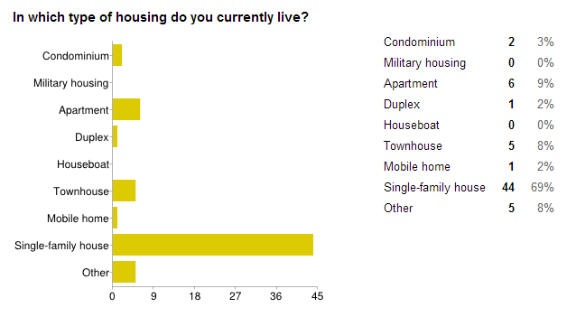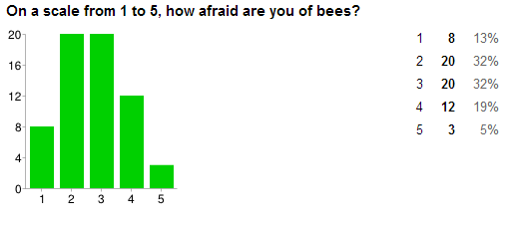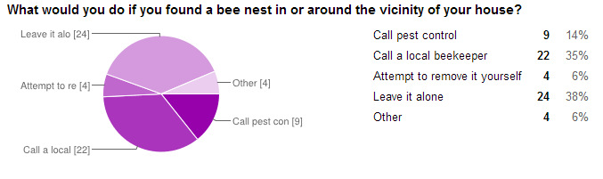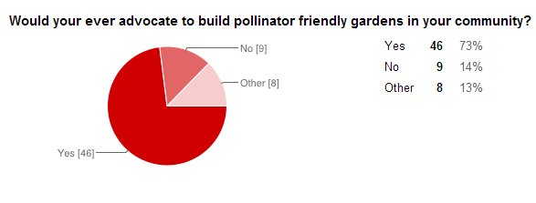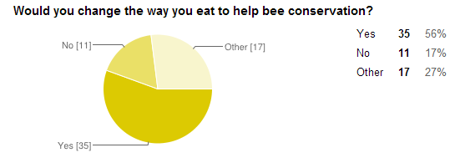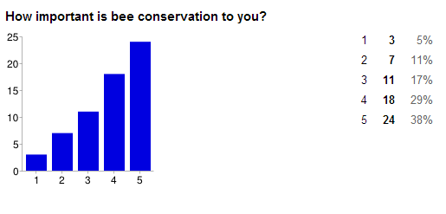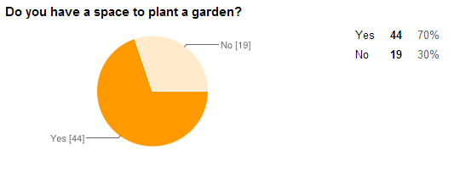

Works Cited
Cloyd, Raymond A., Philip L. Nixon, and Nancy R. Pataky. 2004. IPM For Gardeners. Portland: Timber Press.
2009. Vanishing of the Bees. Directed by George Langworthy and Maryam Henein. Performed by Hive Mentality Films & Hipfuel Films.
Neighborhood Pesticide Action Committee. 2009. "Inner-City Pesticide Use as an Environmental Injustice." Jamaica Plain.

Regional plant lists are available the Xerces website http://www.xerces.org/pollinator-resource-center/ These are the best plants to use.
Annuals are plants that take a full year to complete their life cycle. Perennials are plants that take more than two years to complete their life cycle.
They even list the types of bees they ship to each region! This is to prevent introducing them to areas they are not native to.

