Sustaining Native Bee Populations in Developed Areas
Senior capstone research paper
Kelly Zhang

I would like to dedicate this section to all the people who helped me out with this project and got me to where I am right now:

Mr. Finnegan, Mr. Chinosi, Ms. Samaha, Ms. Palisoul, my family, the CAPS cohort, Michael Ramos, Marcia Cooper, Kelly Gill, Jennifer Steel, Beth Schroeder, Ted Kuklinski, Noah Wilson-Rich,
Kaat Vander Straeten, Roger Wiegand, Brendan Hathaway, and Pam Phillips.

Thank you so much!!

Contents
Abstract 2
Introduction & Background 3
Survey Results & Evaluations 4
Conservation Education 7
Educating the Public 7
Pesticide Use 7
Building Habitats 9
Conclusion 15
Appendix 16
I. Nest/Hive Structures 16
II. Are Honeybees Competitive with the Native Bees? 18
III. Survey Results 18
Works Cited 22

Abstract

We all hear about the honeybee on a population decline, but have we ever considered native bees a part of this too? Native bees have been subject to habitat destruction and pesticide poisoning through human action, especially in urban and suburban areas. This research paper is dedicated to finding ways in which people can partake in bringing back native bees to the cities. In the latter half of the paper, I will report my findings and evaluate how Newton does on native bee conservation.

Introduction & Background

Native bees are all around us, yet we don't value them as actual bees like we do with the honey bee. The very few that people are aware of, are typically bumblebees and carpenter bees but those are only a few out of the 4,000 that exist in the United States. Just as many native bees provide our plants with pollination services, if not more, than our honey-making friend. (Moisset and Buchmann 2011) With the recent Colony Collapse Disorder ordeal surrounding honeybees, many have been chanting “Save the bees!” but should we really be saying that if the word “bees” only means honeybees?
There's a difference between the honeybee and the native bee. Honeybees originated from Europe and were brought to North America by colonists for honey stores. (Turpin 1999) Honeybees are social insects, meaning they live in a colony with infertile female worker bees and a single fertile queen bee. Some native bees are social too, such as the bumblebee and various species of sweat bees, but the remaining majority is solitary, meaning each female bee is its own queen and lays its own eggs. Unlike the honeybee, native bees do not produce honey, and those that do produce only enough for the young to feed on. Honeybees are not so picky with the flowers that they pollinate, but they do not have certain abilities to efficiently pollinate specific flowers. The tomato plant for example, can only be pollinated by buzz pollination, a technique in which a bee vibrates its wings to shake the pollen from the flower and onto its body. Bees like the bumblebee are able to perform this. (Spivak 2013) Other bees like gourd bees specialize in pollinating cucurbits (melons, squashes). Even though they are the same size as the honeybee, gourd bees can pollinate them several times more efficiently per flower per bee than the honeybee can. (Moisset and Buchmann 2011) Not all bees live in hives that are up on trees either. 70% of native bees actually burrow into the ground like their ant cousins. The remaining 30% burrow in hollow logs and stems. (The Xerces Society 2011) Even though these bees do not create waxy honeycomb hives, the concept in which the burrows are built are very similar. (See Appendix I)
For my research project, I have focused on conserving native bee populations in developed areas (urban and suburban). Coastal regions typically have the highest biodiversity of animals and insects but they are also where many of our big cities reside in. (The Xerces Society 2011) By destroying the native land for infrastructure, we are essentially destroying the homes of several hundred, if not more, species. Misuse of pesticides are a problem for any remaining species. It is important to educate the public about these issues in order to help sustain native bee populations in developed areas. To do so, I will be going through ways a person can help their local bee populations out, even if they live in a small apartment complex in the city.

Survey Results & Evaluations

During the course of my research on the subject on bee conservation, I wanted to see how much people know about bees, and how they responded to certain situations related to bees. A Google forms questionnaire was created and featured three categories: general information, opinions on bees, and conservation. (See Appendix III for charts) General information asked for things like age, region, type of area (urban/suburban/rural), and type of housing (apartment/condo/single-family house). Questions for opinions on bees asked survey takers “What would you do” and “What do you know” types of questions on bees to gauge their general understanding. Conservation was asking survey takers whether or not they were willing to do certain tasks (planting a garden, donating money) to understand how important bee conservation is to the public. My predictions were that the public would be very supportive towards the cause for conserving bees but knew little about bees apart from a honeybee. For the most part I was right but in the wrong light.
I received 63 responses, which may be too little to properly perceive the publics’ opinions. The data recorded may not accurately portray how the public views bees. From the sample of 63 people, almost 90% were 29 or younger. More than 50% of the responders don’t find bees especially terrifying and also consider bee conservation important to extremely important, meaning that bees will not be looked at in the negative light 20 to 30 years from now. 73% said that they would actively advocate to build pollinator friendly gardens in their communities and 56% said they would change the way they ate to help bee conservation. Even though about 80% of the responses came from people living in urban or sub-urban areas, there was a mix of responses on how important bee conservation was to them and how willing they were to actively advocate. When asked what they would do the if they found a bee nest around the vicinity of their home, there was a threeway split between “Leave it alone”, “Call a local beekeeper”, and “Call pest control”/ “Attempt to remove it yourself”/ “Other”. Out of those who answered “Attempt to remove it yourself” responses were either burning it down or spraying it down.
In addition, the survey asked people “How many kinds of bees can you list off the top of your head? What are they?” A majority have correctly identified at most 2-3 bees. In order of most frequently identified to the least are: honeybee, bumblebee, and carpenter bee. All others were identified about 10-20 times, and included insects that weren't bees (hornet, yellow-jacket, and wasp were the most common out of this category).
So what does this all mean? People are aware of bees, and care for their survival. On the other hand, they are uneducated on how to identify them and how to properly deal with one. The solution is to find a way to guide the public towards the right resources and shed light on common misconceptions. Experts whom I had the opportunity to speak with, also had similar insights. Kaat Vander Straeten, a beekeeper and environmental activist in Wayland, emphasized the importance of educating people on bees, especially if you plan to raise them. She spoke of a time where her friend in Watertown started beekeeping but did not discuss about it with the neighbors. Because of that, Kaat’s friend is unable to keep bees now. Kaat’s own neighbors showed concern over the bees but once she educated them about the matter they came to an understanding. (Straeten 2014) As for Kelly Gill, a Xerces pollinator conservationist specializing in the Northeastern and Atlantic area, she emphasized learning about the current concerns there are on bees. Then, to utilize that knowledge to sustain and protect the bees that do us service. (Gill 2014)

Conservation Education

Educating the Public

Educating the public is one of the major hurdles in achieving native bee conservation. In an environment where people may not have the time or space to cultivate bees, awareness is key. It is vital that people are given accurate information about bees, or else misconceptions will occur. Just because some bees sting doesn’t mean all bees do. Knowing how to differentiate bees, how to tell between native plants and non-native ornamentals, how to use pesticides appropriately, or even being aware of the pollinator situation and calling your local legislator about it – all of can contribute significantly to the conservation of bee populations.

Pesticide Use

Pesticides may aid us in growing beautiful crops but it does not do any justice to the insects and animals that are pollinating them. In the context of bees, using pesticides diminishes populations of these pollinators and given that they are harmful enough, pesticides can even have long term effects on its consumer. In the 2009 documentary film “Vanishing of the Bees”, French scientists have said that systemic pesticides such as neonicotinoids can affect bees across generations. These types of pesticides are applied on the seeds, making the pesticide spread throughout the plant as it grows, sometimes even to its reproductive system where the bees harvest pollen from. While bees that collected the pollen might not be immediately affected, active ingredients in these pesticides can cause genetic alterations that can make offspring more susceptible to diseases. (Hive Mentality Films & Hipfuel Films 2009)
In urban environments, it’s even worse. Unlike farmlands, where the government can regulate how much pesticide is distributed to farmers, urban landscapes are oversaturated with store-bought pesticides. In a 2009 study by Northeastern University, 1/3rd of the Jamaica Plain neighborhood is at a medium to high environmental risk. Most of this is due to toxic wastes and the excess use of pesticides. It was explained in the report that when spraying, companies do not coordinate spray times with each other and often spray them in the same areas at the same time. It has gotten to the degree of toxicity where not just bees are at risk but also humans— children especially. (Neighborhood Pesticide Action Committee 2009) This is only one small community out of the many in Massachusetts. One might argue that other areas may not spray pesticides as much, but that doesn't mean that such places should be excused. Bees are all still affected by this. We use pesticides, herbicides, and fungicides to eliminate the things we consider ugly in our gardens or natural landscapes, but what happens if the creatures that make our environments beautiful and flourishing go down with them as well?
There is also an alternative to using bee-safe pesticides, but it has proven ineffective. Like all chemical drugs, there's always a negative side-effect. Unlike common pests, bees are not well adapted to pesticides overtime. As quoted by Joe Traynor from Bee Source,
“Compared with humans, honey bees have a relatively fragile immune system. A less than robust immune system means greater susceptibility to pests and diseases. A highly developed immune system, however, diverts resources that might otherwise be used to benefit an organism – in the case of bees, more brood rearing and more foraging for pollen and nectar; there is no free lunch. ” (Traynor 2009)

Even though Traynor talks about the honeybee, one can say the same about native bees. They too, need a diversity of resources to collect for their young and are genetically close enough so that there are no major differences in how their immune system is formed. So even when a pesticide is labeled “bee-safe”, it should still be carefully used and treated as if it were a regular pesticide.

So what can be done about this? Pollinator Partnership states that “emphasis must be on a thoughtful, educated approach to chemical use, and to a reduction and ultimate elimination of its use.” (Pollinator Partership n.d.) One of the main problems when it comes to applying pesticides is when to spray them. If one must spray pesticides, they should consider the times in which pollinators come out to forage.
Eliminating pesticide use will certainly allow pests into your garden, but through proper management of your garden, you can strengthen it by building a diverse habitat. By doing so, this attracts predator insects that prey on pests.

Building Habitats

Habitat building for native bees is the best way to sustain their survival. This can be done in your own garden, or at one that is run by the community. Community gardens are great for people who can’t grow one at home. If there isn't a community garden in your area, there’s always the opportunity to start one. Growing a garden not only strengthens the community, but also the native life that frequent the area, like bees.
Because of their long history with certain native bees, native plant species are a wonderful addition to a garden. In an email conversation with Roger Wiegand, an entomologist, he said that he identified over 40 different native bee and wasp species visiting the nepeta in his yard in a 15 minute interval. However, planting one type of flower is not enough. It is extremely important to have many different types growing in your garden as “diverse or complex landscapes, which contain a variety of plant types including flowers, shrubs, and trees, tend to have higher rates of natural enemies (particularly parasitic wasps) than simple landscapes do.” (Cloyd, Nixon and Pataky 2004) You wouldn't want to stop at a restaurant that only sells one dish. A mix of annuals and perennials is preferred since not all the flowers in your will die at once when the fall and winter season comes around.
Planting flowers of a variety of shapes and sizes will also attract certain bees which specialize in collecting from them. Flowers like clover which have hard to reach nectar supplies attract specialty bees like bumblebees and mason orchid bees. On the other hand, flat surfaced flowers such as cosmos attracts a wider variety of bees due to easier accessibility to pollen and nectar. Planting shrubs and bushes are good for giving bees shelter from outside dangers. One of the biggest factors contributing to population decline is the removal of these shelter plants. Without these, bees are more susceptible to precipitation, temperature extremes, and predators. (The Xerces Society 2011)
The use of cover crops greatly benefit pollinators such as bees. Cover crops are low growing plants used to maintain the quality of the ecosystem around it. Examples include wheat, mustard, and chickpeas. Many of its benefits include maintaining soil pH levels, combating weeds, and nutrient retention in the soil. While the upside is that there’s no need to apply herbicides to your garden, the downside to this is that it attracts a plethora of insects, both good and bad. Bees happen to be one of good guys, looking for a place to hide and rest in during their foraging trips. Alfalfa is an example of a cover crop and is a favorite of the bees. Thankfully, growing alfalfa can also attract predatory insects to combat the pests. (Sustainable Agriculture Research & Education 2012)
If cover crops are not your cup of tea, another tip is to let the grass on a lawn to grow long so as to leave added protection for any of the grown-nesting bees. If you must cut the lawn, it is best to raise the blade so that the grass is not cut extremely short. Surprisingly enough, bee habitats can be destroyed through the act of mowing your lawn. (The Xerces Society 2011)
Currently, there has been a widespread movement to encourage habitat establishment for pollinators in the United States. John Schwartz from the New York Times writes that,
“The federal government has announced a new $3 million program to step up support for honeybees in five states in the Upper Midwest…
The new program will encourage farmers and ranchers to grow alfalfa, clover and other crops favored by bees and which serve a second purpose of being forage for livestock. Other proposed changes in practices include fencing property for managing grazing pastures in rotation so that they can replenish, leaving living plants for the bees.
Jeffery S. Pettis, who leads bee research at the federal Agricultural Research Service in Beltsville, Md., said the effort to get farmers to plant more crops with pollinators like bees and butterflies in mind was intended to help the creatures weather the challenges of pathogens, parasites and pesticides. “If they have a good nutritional foundation, they can survive some of the things they are faced with,” Dr. Pettis said.” (Schwartz 2014)

While this government program does not focus on developed areas, it does show that something is done about this issue, and that practices done out in the farm can be modified so that it can be applied to the cities. In case studies, there has been a push to set up multiple urban gardens throughout all of California. All throughout blooming season, several bees native to California would show up and visit these gardens. Organizations like Xerces have also been pushing to establish pollinator friendly environments in places such as Minnesota and Wisconsin. Here in Boston, Massachusetts, a small business called BestBees has been setting up bee hives and bee nests on the rooftops of company buildings. While these beehives are specifically for raising honeybees, similar ideas can be implemented so that companies can endorse the installation of native bee hives and pollinator gardens as well. Companies like “Crown Bees” have been following this approach by selling mason bees and mason bee nests.
Of course, what goes around comes around. Building habitats for bees will definitely cost money, time, and space. Despite this, what we get in return is much bigger. More habitats mean more bees and pollinators. More bees mean more pollination services. More pollination means more fruit obtained. Not only is it beneficial to the environment but also to our well-being. Kaat noted that beekeeping has psychologically impacted her in a positive way. And it wasn't just her; beekeepers in her community said the same thing. It's the feeling of being able to do something, that “yes, I can do this and I be part of the change.” (Straeten 2014)
Building bee nests/houses is another way to help the survival of bees, especially in areas where there is a lack of places for tunnel-nesting bees to find hollow areas to live in. This allows bees around the area to have a safe place to rest and lay their eggs. For part of the field study of this project, I have decided to build several bee houses for tunnel nesting bees. It wasn’t as smooth as I expected, for many reasons. First was building the nests themselves. I have no experience in woodworking, nor did I have understanding of the types of materials I was supposed to use. However, guides like the one from Xerces helped me tremendously. The second issue was finding places to put the nests. Newton’s environmental leadership community, Green Decade, has lent a tremendous hand in putting up an ad on their e-newsletter, but unfortunately I did not receive any replies from their subscribers. Regardless, I have put them up outside of my house, and my grandparents’ house. I built two types, one with holes drilled into a log and one with hollowed out bamboo poles. The process is fairly simple, though certain precautions need to be taken in order for the bees’ health to not be at risk when they are inside the housing. The other issue to this is the timing and weather. While I have left these houses out for the bees to nest in, the New England area has been subject to a lot of temperature extremes as of late, making even bee sightings difficult.
I have also been doing bee watches in the Newton area. Unfortunately, due to the sporadic weather, bees hadn’t been appearing until early May. I talked to Pam Philips, a local bee enthusiast mid-April and she has confirmed that,
“The cloudy cool weather lately has not been the greatest for bees. It's also still pretty early. This time of year on sunny days you'll most likely see bumblebees hunting for nest sites. On warmer days honeybees will be foraging. You may also find small brown bees emerging from the ground or lawns. These are Miner bees. They are only active for a few weeks in spring.” (Phillips 2014)

Fortunately, when the bees did start to show up I had the opportunity to take photos of a few of them. After seeing the same types of bee species hanging around in the same area for about two to three days, I figured that there must have been a nest nearby the area. There was even a mating attempt going on with two carpenter bees at one of the areas. On the downside, I have not yet identified the lesser known native bees, like the miner bee that Pam mentioned. They’re smaller in size and some are not in the typical black and yellow, making them easily mistaken for a beetle or a fly. With that in mind, it takes time and experience to be able to identify and differentiate bee species from each other.
Another thing that I kept in mind while going on these bee watches is the flowers that these bees visit. I found that despite how lush and green Newton appears to be, many of the blooming flowers that were popping up were not native plants, but non-native ornamentals. When going down Walnut St. and Watertown St. I see rows and rows of giant Bradford pear trees blossoming their smelly white flowers. These trees are considered as invasive species, but both the honeybees and the native bees seem to favor their smelly scent as an indicator for rewarding nectar. At the same time, I have been seeing honeybees feasting on native blue violets popping up all over the sidewalk grassbeds. Even though they are considered weeds, flowers like the blue violet still provide nectar for bees to harvest from. The myriad of tulips that have been blooming, however, have not been attracting many bees within these past days. This sort of situation has stumped me and questions such as “What makes the flower attractive to bees?” “Why are some flowers more preferred to others?” often pop up in my head now. This sort of situation has made me realize how important it is to understand the plants rather than just looking up names and say that bees like them.

Conclusion

Native bees are essentially the underdogs of bees and therefore should get more attention from us, who depend on them for food and beautiful flowers. And they need us especially in the cities, where habitat is lacking and use of toxic pesticides is frequent. We can help out by learning more about them and ways we can conserve and sustain their population. There are certainly more issues surrounding native bees but in the context of conserving them in developed areas, I believe that habitat conservation and restraint towards pesticide use is the most important.
If the bees die out, pollination for flowers will be scarce, and then crops would have to be imported from other countries and be pollinated by humans instead. Such methods would inflate the pricing of the everyday foods we eat. As it is now, bees are scarce and this is an issue that must be dealt with as soon as possible. Thankfully, there are plenty of organizations that are actively finding solutions towards pollinator conservation. The Xerces Society and the Pollinator Partnership are two of the many more organizations out there actively looking for solutions. Their efforts alone aren’t enough to solve the problem. It takes entire communities to work together to make a difference. If every family were to follow an advice given from this research paper, it would benefit the growth of the native bee population, have greener cities, and ultimately connect us to the nature surrounding us so that we can change our environment for the better over the coming years.

Appendix

Nest/Hive Structures
Honeybees make their hives in a hexagonal structure. Each of these hexagons are used as cells to raise brood or to store honey in.
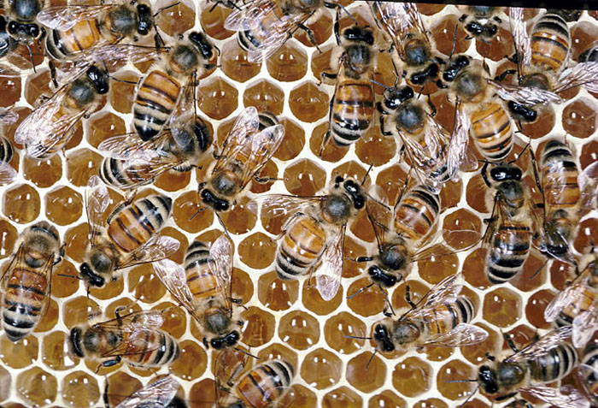
Figure . Image on honeybee colony storing honey in cells (Photo credit © scott camazine)
Native bees on the other hand have a range of different nest structures.
Bumblebee nests are somewhat similar to honeybee nests, though they are less organized. Instead of the hexagonal shape that honeybees make, bumblebees make pot-like cells to raise their brood and store their food in.
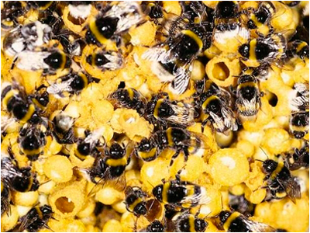
Figure a bumblebee colony working on their food supply (photo credit © dragonfli.co.uk)
Tunnel nesting bees horizontally stack their brood and separate each with a cell wall. What the bee uses to seal wall depends on the type of bee. Leafcutter bees uses leaves from nearby areas to make their cells while mason bees use mud.
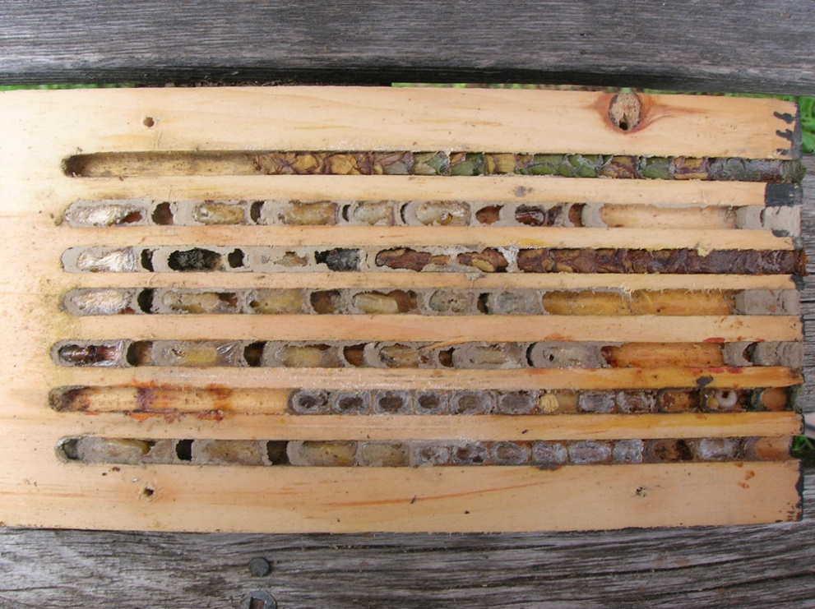
Figure different species of tunnel nesting bees and wasps house inside cavitied wood block
(Part of the pink bee condo project in toronto)
There are also ground nesting bees, where bees create tunnel nests underground much like how ants build their colony. If you see several bees frequenting over a dry patch of ground with holes around, it’s likely that there’s bee nests underneath.
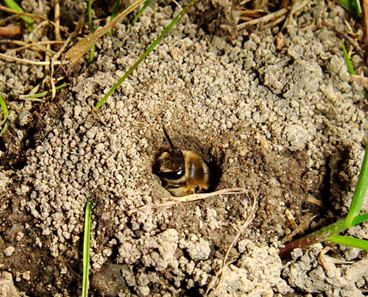
Figure Cornell graduate MArgarita M. Lopez-Uribe is studying population genetics of this ground nesting solitary bee (Colletes inaequalis)

Are Honeybees Competitive with the Native Bees?
Honeybees are non-native in the United States, which have brought up worries that they are outcompeting with the local bees for resources. There has been debate between whether or not this is actually true. Some say that honeybees directly affect how the surrounding species perform and as a result have smaller numbers population numbers within a given area. . (Ginsberg 1983) (Jha and Vandermeer 2009) (Kim, Williams and Kremen 2006) (Schaffer, et al. 1983) (Thomson 2004) On the other hand, experts I have spoken to believe that there is no impacting issue between honeybees and native bees. Kaat said that the honeybees that she raises cooperate well with the native bees that frequent her gardens. Kelly also believes that honeybees do not affect native bee populations, and that both should be considered important to help conserve. As for me, I agree with Kaat and Kelly. I also believe that this is not the right time to be pointing fingers at other bee species since all of them are at risk right now.

Survey Results
The following images below are visual charts of the results from General Opinions on Bees survey that I conducted.
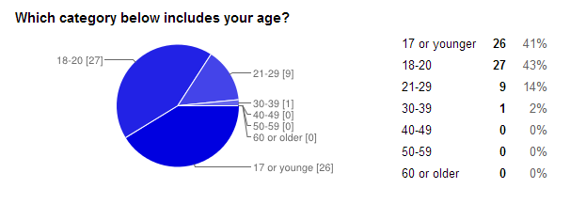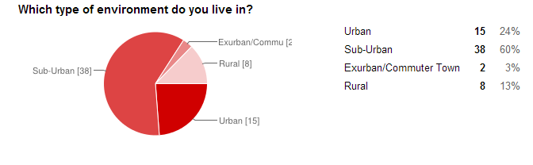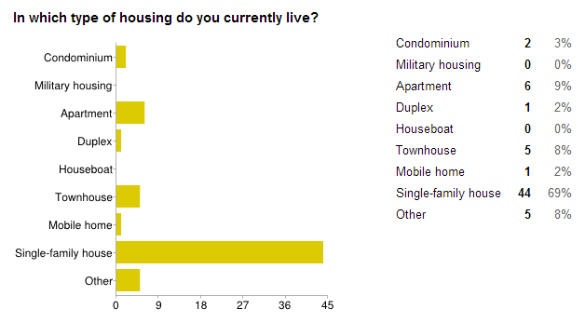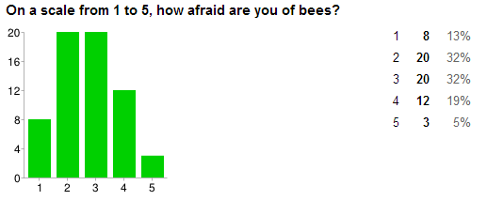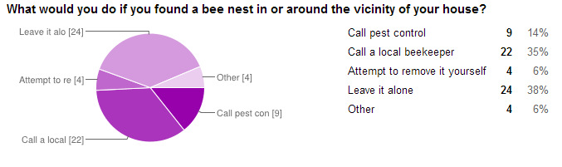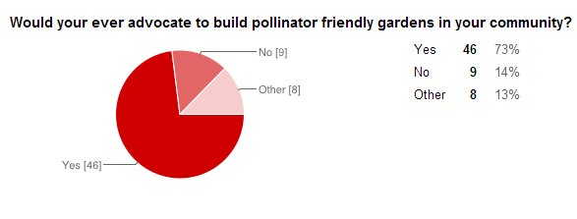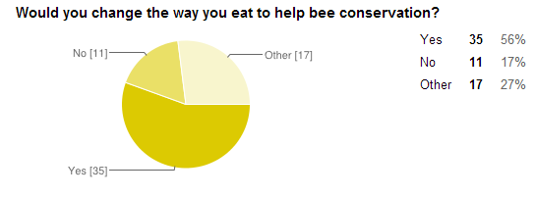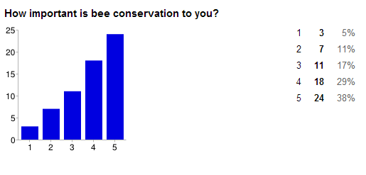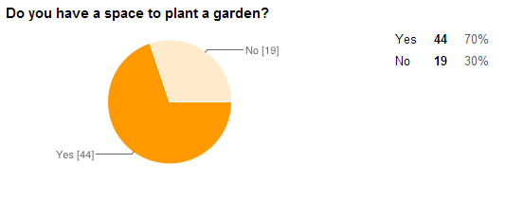

Works Cited
Cloyd, Raymond A., Philip L. Nixon, and Nancy R. Pataky. 2004. IPM For Gardeners. Portland: Timber Press.
Gill, Kelly, interview by Kelly Zhang. 2014. Email Interview (April 1).
Ginsberg, Howard S. 1983. "Foraging Ecology of Bees in an Old Field." Ecology 165-175.
2009. Vanishing of the Bees. Directed by George Langworthy and Maryam Henein. Performed by Hive Mentality Films & Hipfuel Films.
Jha, Shalene, and John H Vandermeer. 2009. "Contrasting Bee Foraging in Response to Resource Scale and Local Habitat Management." Oikos 1174-1180.
Kim, John, Neal Williams, and Claire Kremen. 2006. "Effects of Cultivation and Proximity to Natural Habitat on Ground-Nesting Native Bees in California Sunflower Fields." Journal of the Kansas Entomological Society 309-320.
Neighborhood Pesticide Action Committee. 2009. "Inner-City Pesticide Use as an Environmental Injustice." Jamaica Plain.
Phillips, Pam. 2014. Native Bee Ranching. Accessed April 2014. http://nativebeeranching.com/.
Schaffer, William M, David W Zeh, Stephen L Buchmann, Suzanne Kleinhans, M. Valentine Schaffer, and Jeb Antrim. 1983. "Competition for Nectar between Introduced Honey Bees and Native North American Bees and Ants." Ecology 564-577.
Straeten, Kaat Vander, interview by Kelly Zhang. 2014. Phone Interview (April 21).
The Xerces Society. 2011. Attracting native pollinators: protecting North America's bees and butterflies. North Adam: Storey Pub.
Thomson, Diane. 2004. "Competitive Interactions between the Invasive European Honey Bee and Native Bumble Bees." Ecology 458-470.
Traynor, Joe. 2009. Immunity and Resistance in the Bee Word. December. Accessed May 8, 2014. http://www.beesource.com/point-of-view/joe-traynor/immunity-and-resistance-in-the-bee-world/.
Wilson-Rich, Noah, interview by Kelly Zhang. 2014. Email Interview (April 21).

Colony Collapse Disorder started around 2008 and has been receiving media attention for several years since then. However, this issue applies mostly to honeybees and is outside the scope of this paper.
The Xerces Society is a non-profit organization that focuses on pollinator conservation.
Annuals are plants that take a full year to complete their life cycle. Perennials are plants that take more than two years to complete their life cycle.
They even list the types of bees they ship to each region! This is to prevent introducing them to areas they are not native to.

